1. Calculate (i) the potential at a point due a charge of 4 × 10−7C located at 0.09m away (ii) work done in bringing a charge of 2 × 10−9 C from infinity to the point.
2. Calculate the electric potential at a point P, located at the centre of the square of point charges shown in the figure.

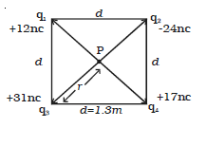

1. If a point lies at a distance x from the midpoint of the dipole, calculate the electric potential at this point.
2. In Fig. below , what is the net electric potential at point *P* due to the four particles if *V* = 0 at infinity, *q* = 5.00 fC, and *d =*4.00 cm?

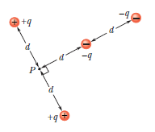

1. The electric potential difference between the ground and a cloud in a particular thunderstorm is 1.2 ×109 V. In the unit electron-volts, what is the magnitude of the change in the electric potential energy of an electron that moves between the ground and the cloud?